

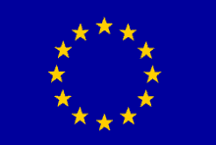

EU Declaration of Conformity with
the European Machinery Directive 2006/42/EC

It is hereby certified that the machinery specified below complies with all relevant provisions of the EC Machinery Directive 2006/42/EC, as well as the national laws and regulations adopted on the basis of this Directive.
Declaration ref. no. | -
Manufacturer: | Anders Nilsson i Östersund AB
Company address: | Åsbacksvägen 6  SE-836 71 Ås
Authorised to compile the relevant technical documentation: | _
Product:
Description: | Saw chain grinder Mod.
Article / Machine no.
We hereby certify that the machinery also complies with all relevant provisions of the following additional EU directives:

Applied harmonised standards: | SS-EN ISO 12100:2010  SS-EN 60204-1 A1  SS-EN ISO 4414:2010

Person authorised to draw up this declaration: | Ander Nilsson |  | Signature:
Title: | CEO
Place of issue: | Ås, Sweden |  | Date:

Any modifications to this machinery shall be subject to review and this declaration shall be declared invalid.

